MODULE: 1
SE – Overview of IT Industry
- What is software? What is software engineering?
A collection of program and data that tells the computer to perform specific task is termed as software.
Software engineering is a branch of computer science that deals with design development,testing and maintenance of software application.
- Explain types of software.
software is set of program and data which tells the computer to perform specific tasks.Software is further divided into five types:
- System software
- Application software
- Driver software
- Middleware software
- Programming software
System software is designed to run computer’s application program and hardware. It cordinates functions and activities of hardware and software both. System software controls the operations of computer hardware and provides platform to all other types of software to work in it.
e.g.,computer language translators,firmware,etc
Application software is a type of software that helps in the automation of task based on users input. It can perforn single or multiple tasks at a single instant of time. It provides graphical user interface to user to operate computer for various funcionality.
Driver software is a type of software that facilitates communication between the operating system (OS) and a hardware device. It acts as an intermediary, enabling the OS to send commands and receive data from the hardware components of a computer or other electronic devices. Drivers play a crucial role in ensuring proper functionality and compatibility between hardware and software.
Middleware software acts as an intermediary layer between different applications or components of a software system. Its primary purpose is to facilitate communication, data management, and integration between disparate systems, allowing them to work together seamlessly.
Programming software known as development tools or environments, are applications that help programmers and developers create, test, and deploy software. There are various types of programming software, each serving a specific purpose in the software development process
- What is SDLC? Explain each phase of SDLC.
SDLC stands for Software development life cycle.SDLC is distributed in 7 different phases such as planning,analysis,design,implementation,testing and integration,maintenance.
- Planning: During this phase, all the relevant information is collected from the customer to develop a product as per their expectation. Any ambiguities must be resolved in this phase only.
2. Design: In this phase, the software design is created, which includes the overall architecture of the software, data structures, and interfaces. It has two steps:
High-level design (HLD): It gives the architecture of software products.
Low-level design (LLD): It describes how each and every feature in the product should work and every component.
3. Implementation or coding: The design is then implemented in code, usually in several iterations, and this phase is also called as Development.
things you need to know about this phase:
This is the longest phase in SDLC model.
This phase consists of Front end + Middleware + Back-end.
In front-end: Development of coding is done even SEO settings are done.
In Middleware: They connect both the front end and back end.
In the back-end: A database is created.
4. Testing: The software is thoroughly tested to ensure that it meets the requirements and works correctly.
5. Deployment: After successful testing, The software is deployed to a production environment and made available to end-users.
6. Maintenance: This phase includes ongoing support, bug fixes, and updates to the software.

- What is DFD? Create a DFD diagram on Flipkart.
DFD is Data flow diagram.Data Flow Diagrams are graphical representations of the flow of data within a system, illustrating how inputs are transformed into outputs through processes.
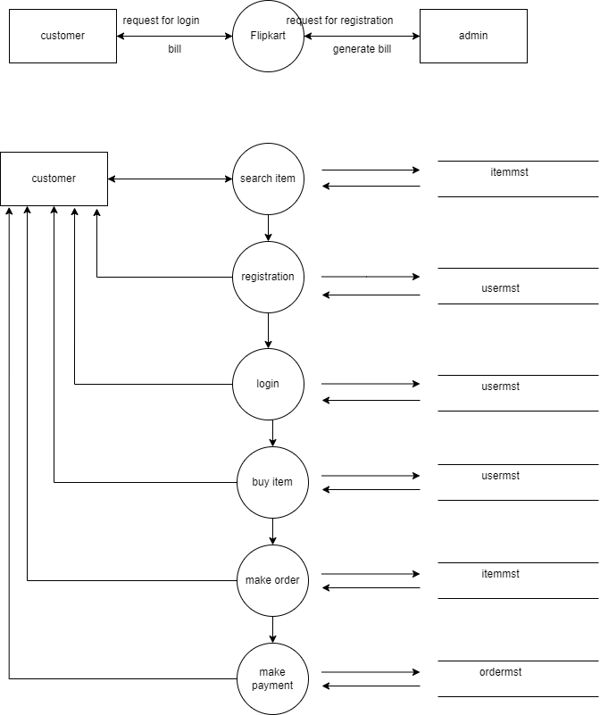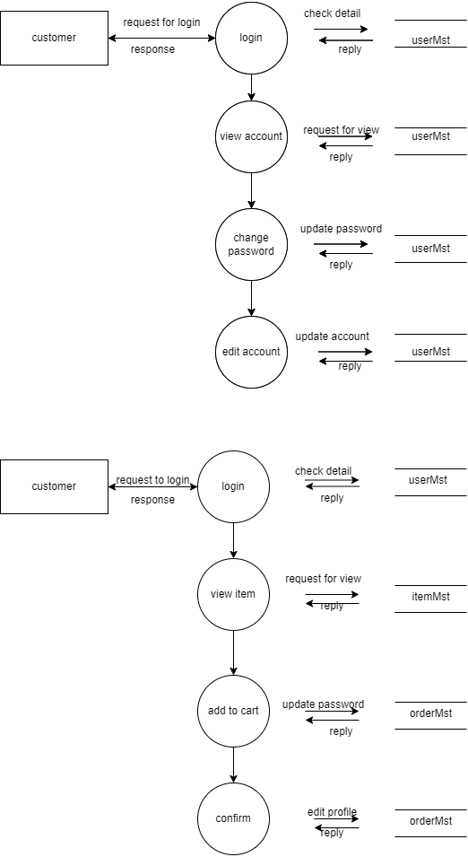
- What is Flow chart? Create a flowchart to make addition of two numbers.
A graphical representation of data or algorithm or code for better understanding the flow with direction.DFDs provide a clear and concise way to understand the information flow and processing within a system.
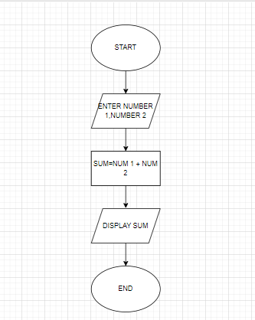
- What is Use case Diagram? Create a use-case on bill payment on paytm.
A use case diagram is a visual representation of the interactions between users (called actors) and a system. It shows the different functionalities (called use cases) that the system provides to the actors and how they interact with them to achieve their goals.

